**Analysis Report**

1. **Data Preparation**

Actions Taken:

• Converted 'Date' column to datetime format.

• Handled missing values by dropping rows with critical missing data and filling others with default values.

• Ensured numeric columns were correctly typed.

Outcome:

* Cleaned dataset ready for analysis with accurate data types and minimal missing values.

1. **Sales Overview**

Actions Taken:

• Analyzed monthly sales to identify trends and patterns.

• Total sales show a fluctuating pattern with noticeable peaks during certain months.

Visualization:

* Line chart showing total sales over time, indicating periods of high and low sales.

Key Findings:

• Significant peaks in sales during certain months, possibly indicating seasonality or successful promotions.

• The average order value is 698.58.

• The total number of unique orders is 64579.

1. **Product Analysis**

Category Distribution:

* Analyzed the distribution of sales across different product categories.

Visualization:

* Bar chart showing the number of sales per product category.

Key Findings:

* Certain categories (eg. T-shirt and Shirt) are more popular, indicating customer preferences.

Size Distribution:

* Evaluated the sizes of products sold and their popularity.

Size

M 12120

L 11504

XL 11402

XXL 9642

S 8816

3XL 7915

XS 5958

Free 1258

6XL 359

5XL 239

4XL 203

Visualization:

* Bar chart showing the number of sales per product size.

Key Findings:

* Specific sizes (e.g., M, L) are sold more frequently, indicating preferred sizes.

1. **Fulfillment Analysis**

* Investigated the effectiveness of different fulfilment methods.

Fulfilment

Amazon 46150

Merchant 23266

Visualization

* Bar chart showing the number of orders per fulfillment method.

Key Findings:

* Certain fulfillment methods (e.g., Amazon) are more popular and potentially more reliable.

1. **Customer Segmentation**

Segmentation by Location:

* Segmented customers based on their shipping state.

Visualization:

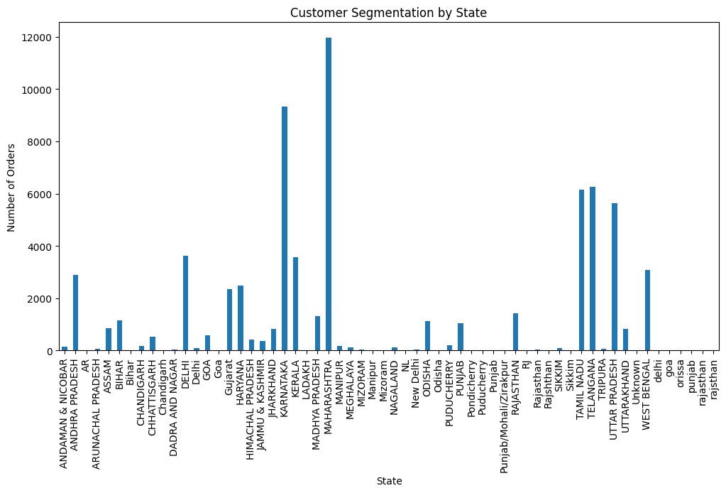

Key Findings:

* Sales are concentrated in certain states, indicating regions with higher customer activity.

1. **Geographical Analysis**

Sales by State:

Analyzed the geographical distribution of sales by state.

Visualization:

Sales by City:

* Analyzed sales distribution in top 20 cities.

BENGALURU 3886214.42

HYDERABAD 2881676.51

MUMBAI 2099563.59

NEW DELHI 2053905.05

CHENNAI 1758151.67

PUNE 1349573.65

KOLKATA 816322.52

GURUGRAM 727951.96

THANE 560361.62

NOIDA 538371.73

LUCKNOW 533581.15

GHAZIABAD 471277.88

AHMEDABAD 445725.48

NAVI MUMBAI 439398.55

Hyderabad 347919.35

JAIPUR 345201.94

PATNA 309289.35

Mumbai 287071.45

BHUBANESWAR 271093.38

VISAKHAPATNAM 259209.12

Visualizaitons:

Key Findings:

* Major cities are significant contributors to sales, indicating urban customer preference.

1. **Business Insights and Recommendations:**

Sales Overview Summary:

* Total Sales: 4511369.79
* Average Order Value: 698.58
* Total Orders: 64579

Actionable Insights

• **Optimize Inventory:** Focus on high-selling categories and sizes to ensure adequate stock levels.

• **Improve Fulfillment:** Evaluate and improve the effectiveness of different fulfillment methods to enhance customer satisfaction and reduce returns.

• **Targeted Marketing:** Use customer segmentation data to run targeted marketing campaigns in high-sales regions and major cities.

Recommendations

* **Inventory Management:** Prioritize inventory for high-demand products and sizes to meet customer needs and reduce stockouts.
* **Fulfillment Strategies:** Analyze and optimize fulfillment processes to improve delivery times and reduce costs.
* **Marketing Campaigns:** Leverage geographical and customer segmentation data to design targeted marketing campaigns, focusing on regions and cities with high sales.